Maryland Legal Services Corporation
Grant Application

Applicant Data

This forms package is available in Microsoft Word format and incorporates some Excel worksheets. To obtain the file on CD-ROM, contact the Maryland Legal Services Corporation or go to www.mlsc.org/grants/grant-application-process to download a copy. Applicants must submit one printed original application and four copies and provide the completed application on disk or by email.

A. General Program Information

Applicant Organization Name:
Address:
City:
State:
Zip Code:
Executive Director:
Phone:
Fax:
E-Mail:
Date Incorporated:
Federal Tax Identification Number:
State Tax Identification Number:

B. Profile of Project for Which MLSC Funding is Requested

Project or Program Name:
Project Director's Name:
Address:
City:
State:
Zip Code:
Phone:
Fax:
E-Mail:
Chair of Board (Name):
Phone:
C. Project Funding Summary

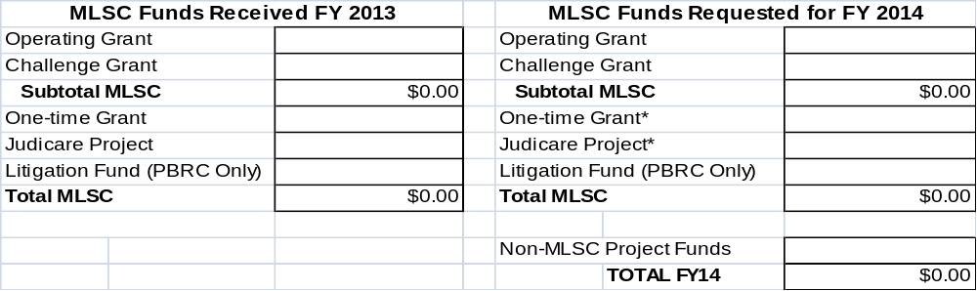

* Separate applications required. Contact MLSC for more information.
Note: The FY 2014 figures should match the detailed budget in Part II, Section C of this proposal.

D. Checklist of Enclosures

Please number and enclose the following supplemental materials with this Grant Proposal. If your organization has previously submitted any of these items to MLSC and it is still in full force and effect, please check the "Submitted Previously" box. If not, please send updated information.

Enclosed | Submitted Previously |  | Attachment
 | N/A | Statement of MLSC Grant Assurances (p. 38) | A
Current Client Financial Eligibility Guidelines-
Direct legal services providers only
 |  | Internal financial control policy
 |  | Proof of tax-exempt, non-profit status
 |  | Board of Directors list
Current Financial Audit Report including:
- The letter to those charged with governance (SAS 114); and
- Internal control deficiency letter (SAS 115) (if applicable).
 |  | If there are any open investigations or legal actions against your organization or any of its employees in relation to their employment, please attach description and relevant documents. (e.g. professional disciplinary complaints, criminal charges or convictions and malpractice law suits or claims)

E. Signatures

Board Chair: Signature:

Executive Director: Signature:

Maryland Legal Services Corporation
Grant Application

Part I:
Applicant Organization
Description

Applicants:

-- Use Part I to provide a comprehensive picture of your current organization, with special emphasis on program(s) that provide civil legal services for the poor and/or related services.

-- Do not include information about proposed or prospective activities- those should be covered in Part II.

Note: Current MLSC grantees reapplying for funding may cut and paste responses to Sections A and B of Part 1 (i.e. “Overview of Organization” and “Description of Legal Services Program”) from the prior year application and highlight changes, if any. However, these sections must be fully completed.

A. Overview of the Applicant Organization

1. Overall Purpose- Please provide an overview of the client and/or community needs your organization currently addresses.

2. Overview of Services and Activities- Briefly list the nature of the services provided by your organization, with special emphasis on legal services for low income people and related activities.
A. Overview of the Applicant Organization (continued)

3. Checklist of Services Provided- Check below ALL categories of service that your organization currently provides.

a. Civil legal services for low-income people (for example, direct legal representation, coordination with private attorneys, legal education, research, pro se training, etc.)
b. Legal training and/or technical assistance for other providers of civil legal services for low-income people, and other activities necessary to ensure the delivery of quality legal services.
c. Services other than the above- for example, health services, counseling, food for homeless people, criminal legal representation, etc.

NOTE: If you have checked "a" or "b" above, continue to the next item; otherwise leave the remainder of Part I blank and go on to Part II.

4. Staff Composition- Using the form below, please indicate the number of Full-Time Equivalents (FTEs) within your organization as of the date of filing this application.

-- A Full-Time Equivalent (FTE) is one person working full-time. For example, two persons, each working half-time, amount to 1.0 FTE. FTE figures are to be expressed in decimals- for example, 1.5 lawyers.

-- "Volunteers" include only volunteers who serve as staff (full or part-time) in your organization. Do not include pro bono attorneys here.

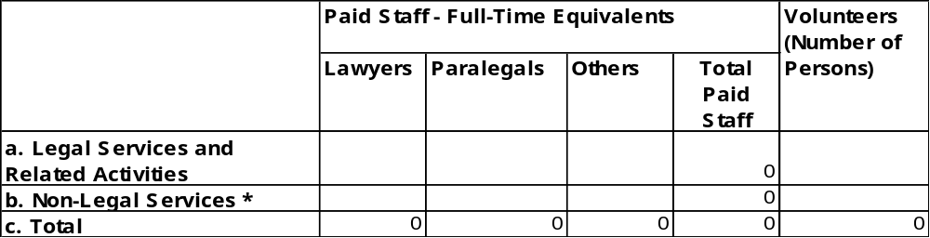

* Non-Legal Services consists of activities unrelated to delivery of legal services to low income people, for example, health counseling or housing services.
A. Overview of the Applicant Organization (continued)

5. Board of Directors- Please attach a list of the names, addresses, and a brief biography of your officers and governing body, and answer the questions below.

a. How often does your board of directors meet?

b. Please describe below how members of your board of directors are selected:
B. Description of Legal Services Program

The remaining questions in Part I apply ONLY to those portions of your organization engaged in "Legal Services"; that is, those services and activities identified in items "3.a" or "3.b" of Section A.

1. Geographic Service Area - Please describe below the jurisdiction(s) (counties, cities, neighborhoods, etc.) served by your legal services program or project- for example, "Queen Anne's and Talbot Counties."

2. Legal Services Offices - Please list below all offices of your organization serving Maryland residents.

- Include office name, address, phone numbers (including toll-free and fax numbers and E-mail addresses). Attach additional pages if necessary.
B. Description of Legal Services Program (continued)

3. Target Population- Describe below the primary client population served by your legal services program- for example, general low-income population, homeless persons, victims of domestic violence, etc.

4. Provisions for Clients Having Special Needs- Describe briefly below any special efforts your program makes to accommodate clients having the following needs:

- Primary language other than English
- Physically or mentally disabled
- Lacking transportation to your office location
- Institutionalized or incarcerated clients
- Other needs particularly applicable to your client population
B. Description of Legal Services Program (continued)

5. Staff Qualifications- In the space provided, summarize the process by which you select staff and the qualifications you require for key staff positions.

a. Describe the steps your program takes to attract and retain highly qualified staff.

b. Describe qualifications (or attach job descriptions if available unless previously submitted) required for:

1. Case handlers (attorneys and paralegals):

2. Case supervisors (e.g., managing attorney):

3. Executive Director:

4. Chief Financial Officer:

B. Description of Legal Services Program (continued)

6. Quality Control Mechanisms- Briefly describe provisions for assuring the quality of services delivered by your organization.

"Case and/or work assignment" includes such activities as staff meetings to decide who will handle certain cases, assignment by managing attorneys, etc.

a. Methods for case and/or work assignment:

b. Procedures for reviewing/supervising work:

c. Provisions for backup and technical support for paralegals, volunteers, law students and other non-attorneys involved in legal service delivery:

d. Methods for determining client satisfaction:

e. Resources used for legal research (for example, law library, Westlaw/Lexis, Internet, etc.):

f. Secretarial and Clerical Support - Provide an overview of how secretarial and clerical support for service providers is provided and by whom. Indicate any special resources that are available for enhancing efficiency or quality (e.g. 1 FTE secretary for 2 FTE attorneys and 1 paralegal).
B. Description of Legal Services Program (continued)

7. Describe other significant quality control methods not covered above. (Attach additional sheet if necessary).

8. Priority Setting and Planning- Please describe below your organization's current priorities related to legal services to low-income people.

a. Briefly describe the process by which your organization assesses community needs and sets priorities for allocating program resources to address them.

b. Specify how regular input is obtained from the indigent population and other interested parties in your service area.

c. Date on which priorities were last updated:

d. Briefly list your current top five service priorities:

B. Description of Legal Services Program (continued)

9. Private Attorney Involvement- Describe how your program involves private attorneys in the delivery of legal services.

-- Client Services consist of direct legal representation of eligible clients by a private attorney or participation in other client service programs, for example, providing legal education or pro se training.

-- Support Services include legal training and/or technical assistance provided by a private attorney to other practitioners who represent eligible clients.

a. Types of programs or projects- check all that apply:

(1) None
(2) Pro Bono- Client Services.
(3) Pro Bono- Support Services.
(4) Compensated- Client Services.
(5) Compensated- Support Services.
(6) Other methods of private attorney involvement.

b. Briefly describe below EACH type of program or project checked above. If (2) or (4) is checked include a description of how legal work is supervised and evaluated.

c. Compensated programs- If you checked (4) or (5), describe in detail the conditions pursuant to which compensation will be provided. (May be done in an attachment.)

d. Other methods- If you checked (6), please describe.
B. Description of Legal Services Program (continued)

10. Cooperation with the Organized Bar- Briefly describe the most significant ways in which your program involves the organized bar in furtherance of the interests of your clients.

11. Cooperation with Other Community Groups- Briefly describe the most significant ways in which your program actively works with other relevant organizations (for example, other legal services providers, community-based organizations, etc.) in furtherance of the interests of your clients, such as joint projects, working with coalitions, etc.

B. Description of Legal Services Program (continued)

12. Involvement of Non-Attorney Volunteers- Describe below any ways in which your program involves volunteers other than attorneys (i.e., paralegals, lay advocates, and law students) in the delivery of legal services, and how appropriate attorney supervision is provided.

13. Fees for Services- If your program charges income-eligible clients for services, please describe in detail; for example, "$25 application fee" or "$25 per hour."

B. Description of Legal Services Program (continued)

14. Technology – Please answer the questions below.

a. Indicate below the program functions for which computers currently are being used extensively in your organization. Check all that apply.

___ __ Client eligibility determination and intake
_____ Case tracking and record keeping
_____ Financial accounting (general ledger, accounts payable, payroll, etc.)
_____ Financial budgeting and planning
_____ Automated or semi-automated legal document preparation
_____ Computer-assisted legal research (Westlaw, etc.)
_____ Desktop publishing (newsletter, client brochures, etc.)
_____ Internal E-mail (approximate percentage of staff who are connected ____%)
_____ External e-mail (approximate percentage of staff who are connected _____%) _____ Web site (if future implementation is planned, indicate date: ________)
_____ Web address:_____________________________________________________
_____ Social networking (Specify:________________________________________)
_____ Fundraising Software
_____ Grants Management Software (Specify:_____________________________)
_____ Other:_____________________________________________________________

b. Year in which your computer system was last significantly updated: ____________

c. Operating Platform (check the primary one):
_____ Windows 2000
_____ Windows 2007
_____ Windows XP
_____ Windows Vista
_____ Windows 7
_____ Other: _____________________________

d. Network
(1) _____Yes _____No – All computers are networked WITHIN offices.
(2) _____Yes _____No – All offices/locations are networked with each other.

e. Internet Access – Percent of all staff having Internet access on their desktop:________%

f. Case management system – indicate software used:
(1)_____Kemp’s “Clients”
(2)_____TIME Case Management System
(3)_____Social Solutions
(4)_____Practice Manager
(5)_____Other – Specify: _____________________

- Word Processing Software and version used (e.g. Word 2003, WordPerfect 8, etc.): _________________________________________________________________________

- Name of Technology Responsible Person: ____________________________________

C. Current Operating Budget

- Organization's Total Current Operating Budget- This question breaks down your organization's total budgeted CASH expenditures for the current fiscal year (July 1 – June 30) into two components: (a) civil legal services for the low-income population and (b) other services (such as health services, non-legal counseling, etc.). If your organization is exclusively a legal services program that primarily serves the low-income population, line (b) will be zero.

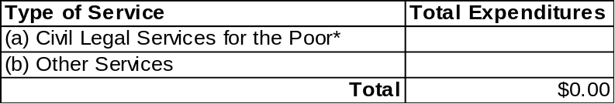

*Provide Breakdown- See "2" on next page.

Period covered by this budget: From July 1, __________ to June 30, __________.

DEFINITIONS:

a. Civil Legal Services for the Poor include such activities as:

- Direct legal services provided by lawyers, paralegals, and other trained persons (including volunteers);
- Community legal education, administrative and/or legislative advocacy; and,
- Activities that directly support such services, including outreach, intake, case assignment, legal work supervision, staff training, and administrative support.

b. Other Services are all others, such as health services, non-legal counseling, housing for the homeless, etc.

c. Total includes funds from all sources including non-MLSC as well as MLSC funds.

Estimate if necessary, using your best professional judgment.
C. Current Operating Budget, (continued)

- Current Budget for Legal Services- Please provide a breakdown of the amount shown in line "a" on the previous page. See definitions of categories on pages 18 & 19. This page covers your organization's total budget for civil legal services for the poor for the current fiscal year (July 1 – June 30).

-- MLSC Operating Funds include Operating Grant and Challenge Grant (if any).
-- Examples of "Non-MLSC funding" include other grants, bar association funds, etc.
-- Important Note: The total Cash Budget should equal item 1, line (a) on the previous page. In kind services should not be included here.

Breakdown of Budget for Civil Legal Services To The Poor

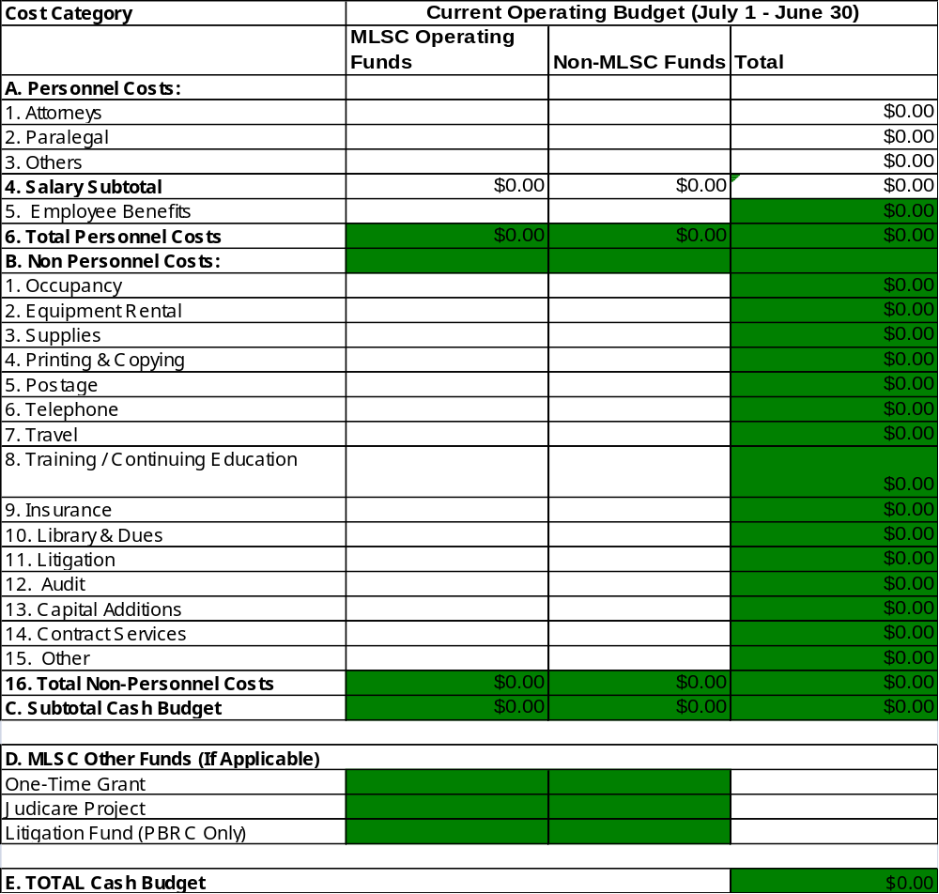

C. Current Operating Budget (continued)

Financial Forms- Explanation of Categories

Attorneys: This category should include all salaries and wages paid to program attorneys, whether employed directly or supervised by the program, and whether part-time, full-time, or temporary.

Paralegals: This category should include salaries and wages paid to program paralegals, whether employed directly or supervised by the program, and whether part-time, full-time, or temporary. Paralegals are persons whose duties consist primarily of such activities as intake interviewing, case investigations, checking court records, legal research, client representation at administrative hearings, and outreach and community work.

Other Staff: This category should include salaries and wages paid to all other program staff, whether employed directly or supervised by the program, whether administrative/clerical staff, students, or others, and whether full-time, part-time or temporary.

Employee
Benefits: This category should include all those commonly accepted fringe benefits paid on behalf of employees, such as retirement, FICA, health and life insurance, worker's compensation, unemployment insurance, and other payroll-related costs approved by the program's board of directors.

Occupancy: This category includes estimated rent, utility payments, and maintenance or janitorial expenses for each office.

Equipment Rental/
Maintenance: This category includes lease or rental expenses for office furniture, fixtures and equipment (except telephone). It also includes an estimate of maintenance costs for that equipment whether pursuant to a service contract or an estimate of individual repair bills.

Supplies: This category includes all basic office accessories and supplies. All equipment purchases under $500 may be placed under this line item.

Printing &
Copying: All materials used in copiers and costs associated with reproducing materials and program literature should be placed in this category.

Postage: All postage expenses should be placed under this line-item.

Telephone: This category includes estimates for the rent of telephone equipment and long distance calls. Similar and related expenses such as E-mail/Internet services or other telecommunications costs should be included as well.

Program
Travel: Travel expenses directly related to specific client matters, administration of the program, etc.
Continued on next page
C. Current Operating Budget (continued)

Financial Forms- Explanation of Categories, continued

Training: All non-personnel costs to be paid for with regular program funds, associated with the training or continuing education of staff members or volunteers would be included here. Examples would be: travel to/from training events, per diem, conference registration fees or tuition, purchase of training materials, rent for facilities used in a training event, etc. Equipment purchased for training with a value in excess of $500 should be reported under "Capital Additions." No program personnel costs should be included here.

Insurance: This category includes professional liability insurance, bonding, property insurance (fire and theft), and liability insurance for property and automobiles.

Library: This category includes expenses for the maintenance and normal expansion of office libraries, including subscriptions to Westlaw/Lexis, periodicals, books, reference materials, and multiple volume sets of law books. Capital additions to the library holdings over $500 should be included under "Capital Additions."

Litigation: This category includes court costs, witness fees, expert witness expenses, sheriff fees, courthouse copying fees, and other expenses incurred but not recovered in litigation on behalf of eligible clients.

Audit: This category includes expenses for auditors.

Capital
Additions: This category includes equipment and library purchases over $500 per item and other major expenses, which occur infrequently. Please provide a separate footnote detailing any capital purchase in excess of $1,000 (e.g. computer; laser printer; copier, etc).

Contract
Services: This category includes payments to private attorneys who provided legal services to clients and service to the program, such as legal counsel for program operations, consultant fees exclusive of those paid for training, use of a computer service bureau, bookkeeping or other accounting services, etc. If the total in this category is over $2,000, please itemize those individual costs in excess of $500 in a brief footnote.

Other: This category includes all program expenses not included above.

C. Current Operating Budget (continued)

- Sources of Funding for Legal Services Activities- Please provide a breakdown, by funding source, of your program's total legal services budget shown on page 17.

The amounts shown should reflect actual CASH funding commitments and/or best current estimates of cash revenue to be received by your program during the budget period.

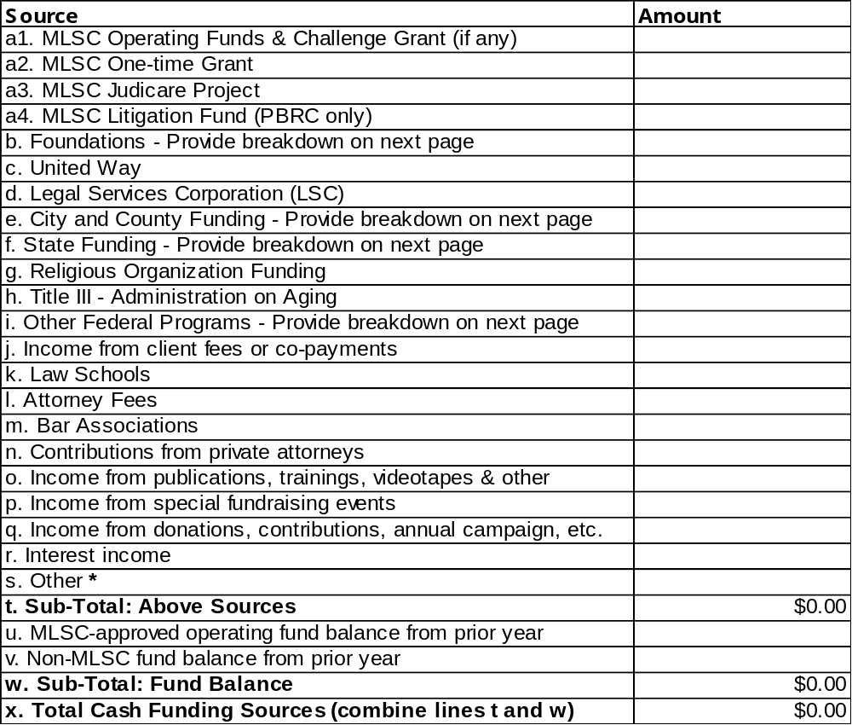

* Other (line s): Include any cy pres awards, agency allocation, general funds, MPILP stipends, etc. and provide a breakdown.
C. Current Operating Budget (continued)

4. Breakdown of Categories b, e, f, i and s:
NOTE: Totals should correspond to related line items in section C.3. on page 20.
(Spell out names of agencies; do not use abbreviations.)

b. Foundations- List names and amounts:

e. City and County Funding- List agency names and amounts:

f. State Funding- List state agencies, programs and amounts [Administrative Office of the Courts funding here]:

i. Federal programs other than d and h- List federal agencies, programs and amounts:

s. Other- Provide a breakdown of any cy pres awards, agency allocation, general funds, MPILP stipends, etc.

5. In-Kind Resources- Please provide below a breakdown of estimated in-kind resources you expect to receive during the budget period for your legal services program- for example, office space, donated equipment, etc. Do not include pro bono services here.

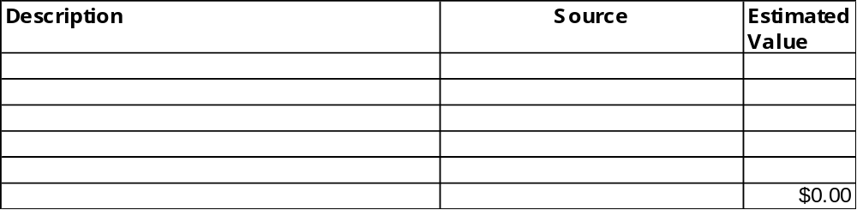

Maryland Legal Services Corporation
Grant Application

Part II:
Grant Proposal

Applicants:

-- Use Part II to provide a comprehensive description of the services and activities you propose to undertake in the future with the help of the MLSC grant you are requesting.

-- All applicants must answer all questions. If your response to a question is exactly the same as your response to a similar item in Part I (for example, your proposed activity will be a continuation of a current activity), simply refer to that item.

-- Describe broadly the program or project for which you seek funding, not just the budget items for which your MLSC dollars will be used.
A. Proposal for MLSC Funding

1. Needs to Be Addressed- Using only the space provided, describe the unmet client and/or community needs to be addressed with the help of MLSC funding. Highlight the extent to which those needs are not currently being met. If these are exactly the same as your response to item A.1 in Part I, simply refer to that item.

2. Proposed Methods for Addressing the Problem- Provide an overview of the planned legal services or other activities that will be used to address the needs identified in "1". If these are exactly the same as your response to item A.2 in Part I, simply refer to that item.
A. Proposal for MLSC Funding (continued)

3. Uses for the Requested Funds- Describe the specific purposes for which the requested funds will be used- for example, "The requested funds will cover salaries and support costs for 1.5 full-time equivalent paralegals."

4. Prohibited Activities- Indicate safeguards that will be used to ensure that the requested funds are not used for specifically prohibited purposes.

a. Check categories (1) through (8) below to indicate any MLSC-prohibited activities that are performed by your organization:

(1) NONE
(2) Fee-generating cases
(3) Criminal defense
(4) Lobbying
(5) Class action lawsuits
(6) Contributions to political parties or campaigns for public office
(7) Actions against law enforcement or court official(s) challenging validity of criminal convictions
____(8) Legal representation for which the State of Maryland is required to fund, and GRANTEE is providing such representation pursuant to a state-awarded contract.

b. Describe briefly below the steps that will be taken to ensure that MLSC funds are not used in carrying out activities (2) through (8):
A. Proposal for MLSC Funding (continued)

5. Special Features of Proposed Program or Project - Describe below any ways in which the proposed program or project differs from or has a more specialized focus than your overall legal services program as described in Part I.

For example, indicate if:

-- it addresses only the needs of a particular segment of your client population, e.g., children.
-- It serves only a particular portion of your geographical service area.

a. Check whether the proposed program or project differs from the overall legal services program as described in Part I:

No Yes - Describe variations in space "b" below.

(1) Geographic service area described in Part I, item B.1.
(2) Legal Services offices described in Part I, item B.2.
(3) Target population described in Part I, item B.3.
(4) Staff qualifications described in Part I, item B.5.
(5) Quality control mechanisms described in Part I, item B.6.
(6) Private attorney involvement described in Part I, item B.9.
(7) Cooperation with other community groups described in Part I, item B.11.
(8) Involvement of non-attorney volunteers, described in Part I, item B.12.
(9) Fees for services described in Part I, item B.13.

b. Describe below any items checked "Yes" in "a". Attach additional sheets if necessary.
B. Proposed Service Delivery System

Please describe in this section the delivery system that will be used to provide efficient, high-quality services with the help of this grant.

Legal Training/Technical Assistance Grant Applicants: Address questions that refer to "clients" (e.g., items 1 and 2) in relation to the target audience of the proposed services; for example, legal services practitioners.

1. Outreach- How will potential clients be made aware of the availability of proposed services? Indicate how the proposed outreach methods address any special problems of the target population, for example, language barriers, physical disabilities, etc.

2. Intake- Where will people come to apply for service, and how will their request be addressed?

a. Where will they come to apply for service?

b. How will a diagnosis be made of their need for assistance?

c. How will denials of service be handled?

d. Indicate roles of workers involved- lawyers, paralegals, receptionists, etc.
B. Proposed Service Delivery System (continued)

3. Direct Services- Provide an overview of the legal assistance or other services that will be provided. Indicate who (staff, volunteers, pro bono lawyers, etc.) will perform this work. If the proposed services are not direct legal representation, indicate what they will be, for example, "backup support for legal services lawyers."

4. Training- Please provide an overview of any training that will be provided to staff, to private lawyers, to volunteers, or to other persons involved in activities funded under this proposal. Indicate who will be trained, by whom, and how many persons you expect to be trained. Indicate why it is necessary.
C. Proposed Budget

1. Budget: Total Proposed Program or Project- Summarize the total CASH budget for carrying out the strategies described in this application. See definitions of line item categories on pages 18 & 19.

-- MLSC Operating Funds include Operating Grant and Challenge Grant (if any).
-- Examples of "Non-MLSC funding" include other grants, bar association funds, etc.
-- A Full-Time Equivalent (FTE) is one or more persons whose hours equal a full-time position. For example, two persons, each working half-time, amount to 1.0 FTE. Express FTE in decimals- for example, 1.5 lawyers.

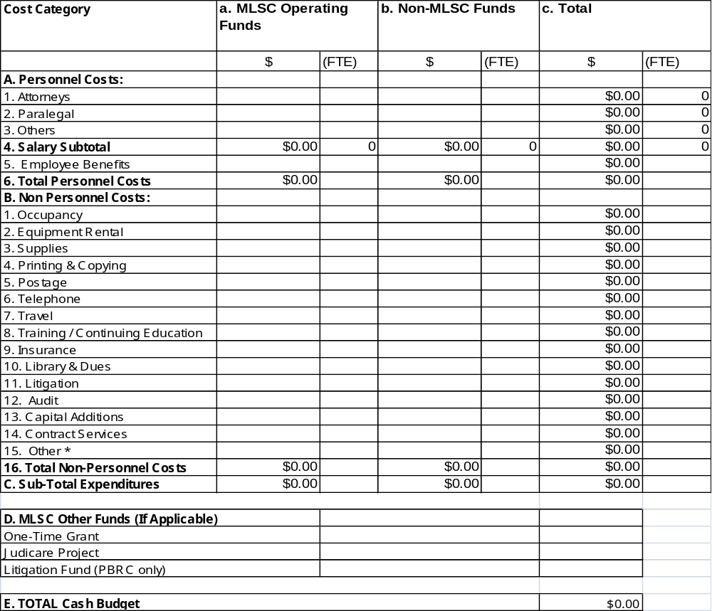

* Other (line 15): Provide a breakdown on the next page if line 15 exceeds 10 percent of the Subtotal, line "C".
C. Proposed Budget (continued)

2. Explanations- Provide brief explanations below if the MLSC operating funds requested exceed the amounts indicated for any of the following:

a. Explanation of "Capital Additions" (line 13, column a) request exceeding $1,000:

b. Explanation of "Contract Services" (line 14, column a) request exceeding $2,000:

c. Explanation of "Other" (line 15, column a) request exceeding 10 percent of the total request:

d. Other explanations or notes to the Proposed Budget on the previous page:
C. Proposed Budget (continued)

3. Anticipated Sources of Funding for Proposed Project- Please provide a breakdown, by funding sources, of the total proposed CASH budget. Note: These figures should cover the grant year for which MLSC operating funds are requested.

- If your organization's fiscal year is different, please pro-rate figures to cover the grant year indicated.
- Include cash receipts only; do not include in-kind or donated services.
- Provide a breakdown on the next page of the amounts reported on lines "b", "e", "f", “i” and "s".

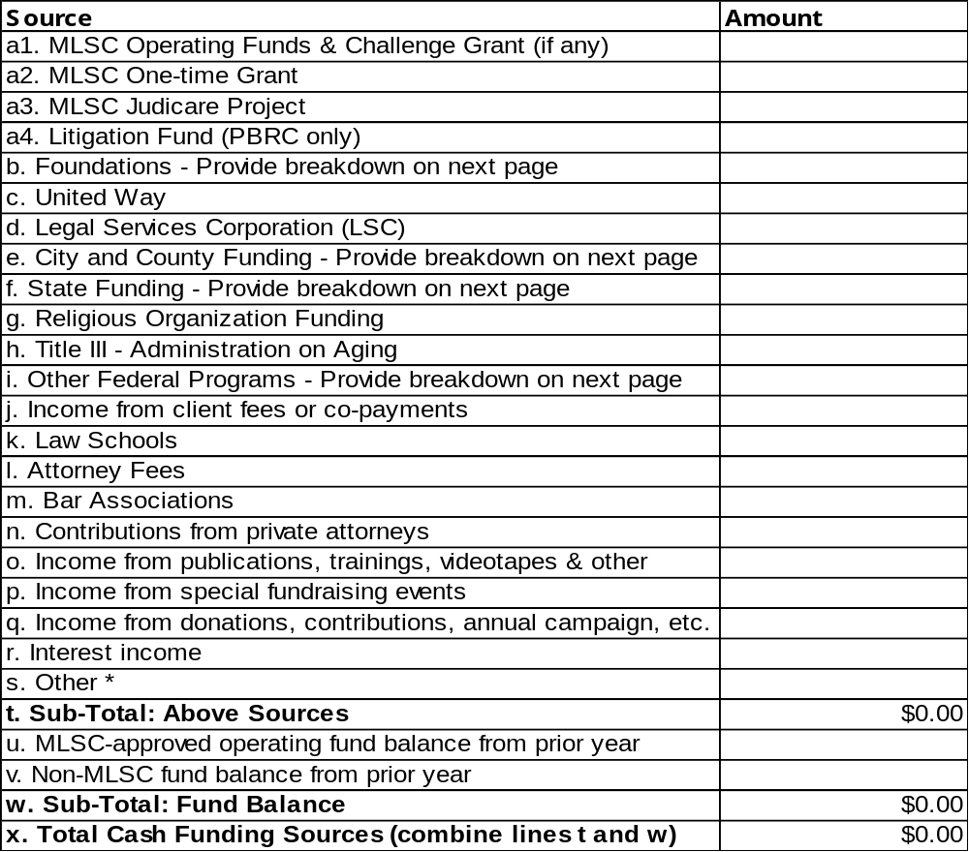

* Other (line s): Include any cy pres awards, agency allocation, general funds, MPILP stipends, etc. and provide a breakdown.

C. Proposed Budget (continued)

4. Breakdown of Categories b, e, f, i and s:
NOTE: Totals should correspond to related line items in section C.3. on page 30.
(Spell out names of agencies; do not use abbreviations.)

b. Foundations- List names and amounts anticipated:

e. City and County Funding- List agency names and amounts anticipated:

f. State Funding- List state agencies, programs and amounts anticipated:

i. Federal Programs Other than d and h- List federal agencies, programs and amounts anticipated:

s. Other- Provide a breakdown of any cy pres awards, agency allocation, general funds, MPILP stipends, etc.

5. In-Kind Resources- Please provide below a breakdown of estimated in-kind resources you expect to receive for the proposed program or project- for example, office space, donated equipment, etc. Do not include pro bono services here.

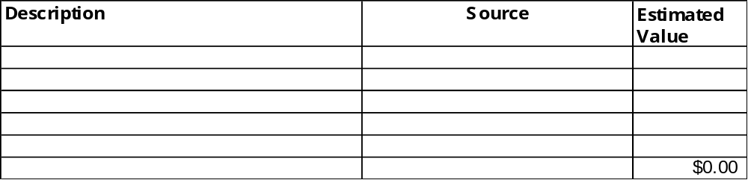

6. Proposed Increase or Change from Current Year's Funding- If you are requesting a funding increase from your current year's MLSC grant or propose to change use (for example, staffing, services provided, etc.), please highlight below what those changes will be or how increased funds will be used.

C. Proposed Budget (continued)
7. Branch Office Proposed Budget- If your proposal requests funding for more than one office, complete the form below for each office to be funded. (Make extra copies of this form as needed.) See definitions of line item categories on pages 18 & 19.
-- MLSC Operating Funds include Operating Grant and Challenge Grant (if any).
-- Examples of "Non-MLSC funding" include other grants, bar association funds, etc.
-- A Full-Time Equivalent (FTE) is one or more persons whose hours equal a full-time position. For example, two persons, each working half-time, amount to 1.0 FTE. Express FTE in decimals- for example, 1.5 lawyers.

Name of Office: Office Director:_____________________________________

Location:_____________________________________ Office Income:

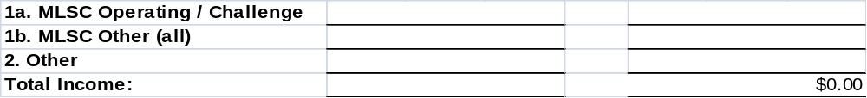

* Other (line 15): Provide a breakdown on the next page if line 15 exceeds 10 percent of the Subtotal, line "C".
D. Proposed Staffing

1. Numbers of Staff- Using the form below, please indicate the total number of Full-Time Equivalent (FTE) paid and volunteer staff persons who will be directly involved in the proposed program or project covered by the proposed budget.

* Include both MLSC and non-MLSC funded staff persons.
* "Volunteers"- include volunteers who work in your program as staff. Do not include pro bono attorneys.
* Do not include staff not related to legal services- for example, medical counseling.
* A Full-Time Equivalent (FTE) is one or more persons whose hours equal a full-time position. For example, two persons, each working half-time, amount to 1.0 FTE. Express FTE in decimals- for example, 1.5 lawyers.

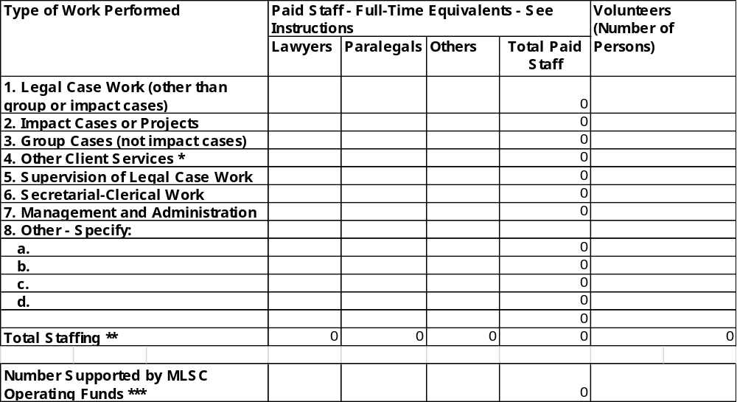
* Other Client Services: Legal education, pro se training and other non-case services provided to low income persons.
** Total Staffing: These numbers should match the ones reported on page 28, Column c.
*** Number Supported by MLSC Operating Funds: These numbers should match the ones reported on page 28, Column a.
E. Anticipated Impacts of This Grant

Please describe in this section the estimated impacts that the proposed activities to be funded under this grant will have in terms of addressing the problems you identified in Part II, Section A.

Note that items 2 - 4 in this section request descriptions of qualitative as well as quantitative impacts.

1. Numbers of Clients to be Provided with Direct Legal Representation - Approximately how many persons will be served during the period of this grant, assuming the total proposed budget you described in Section C is available? Please estimate using your best judgment.

NOTE: Consider past year’s statistics and any other relevant factors. If the increase or decrease is greater than 10%, please explain.

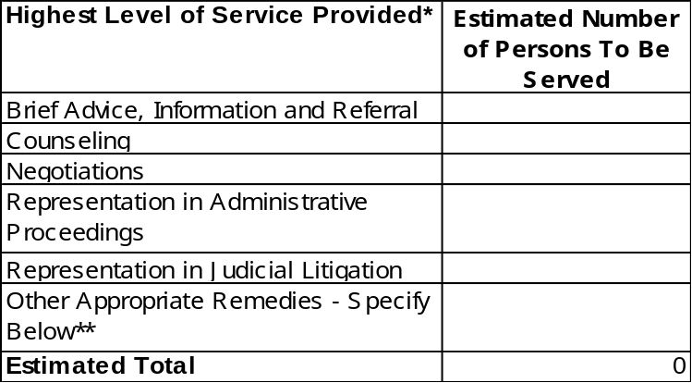

* See definitions on next page.
** If "Other Appropriate Remedies" exceeds 10 percent of the total, please attach a breakdown.

2. Impacts of Other Client Services to be Provided - Please describe below the impacts of other client services (for example, legal education or pro se training) that you expect to result from this grant.

Examples:
- "Approximately 500 people will learn how to avoid unnecessary consumer problems".
- "1,000 immigrants will be informed about the impacts of new INS procedures".
- "250 people will be assisted in filing for divorce pro se".
E. Anticipated Impacts of This Grant (continued)
Definitions: Level of Service
Brief Advice, Information and Referral | Action taken at or soon after intake on behalf of a client that resolved a case requiring a minimal amount of staff time and resources (i.e. approximately 30 minutes or less).
Counseling | Preparing and providing advice to the client (e.g., reviewing relevant information and counseling the client on action that might be taken to resolve the issue or dispute).
Negotiations | Cases are to be reported closed through negotiations when an agreement has been reached between the parties and the issues have been resolved without the filing of a law suit.
Administrative Remedies | This category should reflect cases that were closed during the period which were resolved after suit was filed in an administrative tribunal, regardless of whether the case was resolved upon a decision by the administrative tribunal or settlement between the parties.
Judicial Litigation | This category applies to cases that have been closed during the period which were resolved after suit was filed in a state or federal court, regardless of whether the case was resolved upon a decision by the court or settlement between the parties.
Other Appropriate Remedies | This category should be used when other service categories are inappropriate. For example, the resolution of a case through document preparation, such as the drafting of a contract, will or power of attorney should be included here.  NOTE: A breakdown of the remedies reported in this category must be provided if the number of cases reported here exceed 10 percent of the total cases closed. When the service involves court accompaniment by a non-attorney, include the cases in ‘Other Appropriate Remedies’ and indicate in a footnote the number of such cases that are included in that category.

E. Anticipated Impacts of This Grant (continued)

3. Long-Term Impacts - What impacts, if any, will remain after this grant is over? For example, will resources be created by this grant (a pool of trained people, cooperation among agencies, etc.) that will outlive this grant?

4. Impacts on Opportunities Available to the Poor - What impacts, if any do you expect the activities funded under this grant to have on basic opportunities available to poor people in Maryland? For example, job opportunities; affordable housing; affordable health care; access to education.

F. Additional Comments

Use this space to make any additional comments that will help us evaluate your proposal.

Attachment A
The Maryland Legal Services Corporation

ASSURANCES GIVEN BY APPLICANT AS CONDITION FOR RECEIPT OF AN
MLSC GRANT

(Applicant Name)

Applicant assures that it:

- Agrees to carry out the program for which the funds were requested and report to the Corporation on progress and results.
- Will not use MLSC funds to engage in activities that are restricted pursuant to the Maryland Legal Services Corporation Act, MD Code Article § 11-503, and will in all respects comply with all other applicable terms of Maryland Legal Services Corporation Act.
- Will restrict the use of MLSC funds to law-related activities or purposes that are charitable or educational within the meaning of Section 501(c)(3) of the Internal Revenue Code.
- Will not discriminate on the basis of race, color, religion, sex, age, disability, sexual orientation or national origin against (1) any persons applying for employment or employed by the applicant with respect to any personnel action proposed or taken concerning the applicant or employee; or (2) any person seeking participation in, or the benefits or proceeds of, the program or projects supported in whole or part by this grant and will, upon request, provide a copy of its Non-Discrimination Policy to MLSC.
- Is in compliance with Americans with Disabilities Act of 1990 and will, upon request, provide a copy of its ADA Compliance Policy.
- Will maintain up-to-date professional liability insurance coverage for attorneys that provide direct legal services and will, upon request, provide a copy of such policy to MLSC.
- Is in compliance with current nonprofit audit requirements for policies covering conflict of interest, record retention and whistleblowers and will, upon request, provide a copy of such policies to MLSC.
- Will, upon request, cooperate with all data collection and evaluation activities undertaken by MLSC and give any authorized representative of MLSC access to any copies of all financial records, books, papers, or documents, provided that MLSC shall not have access to any reports, records, or information subject to the attorney-client privilege.
- Will provide audited financial statements for the period in which MLSC funding is received.
- Will provide an auditor's positive assurance statement of grant compliance and/or allow Corporation auditors access to program and financial records to assess compliance with grant contract terms and conditions.
- Understands and agrees that MLSC may, in its sole discretion, grant funds in greater or lesser amounts and/or for greater or lesser periods of time than requested in this application.
- Will provide, upon request, periodic written reports detailing the use of MLSC funds in light of the proposed use described in the grant application.
I have read these assurances and understand that if this application is approved for funding, the grant will be subject to these assurances. I certify that the applicant will comply with these assurances if the application is approved.

Executive Director: Board Chairperson:

Signature: Signature:

Maryland Legal Services Corporation
Grant Application

Part III:
MLSC Grantee
FY 2013 Mid-Year Report

Period: July 1, 2012 through December 31, 2012

Current Grantees: Use this Part to report on the first six months of your current MLSC grant, July 1 through December 31.

New Applicants: This report is not required. Please complete Part IV.
A. Narrative Status Report

1. Snapshot of Achievements - Provide a summary here of significant achievements of your MLSC-funded program or project during this report period.

2. Progress on Evaluation Issues- Please summarize the status of your efforts to address any issues raised in the prior year's MLSC evaluation meeting or any conditions of the grant agreement.

a. Were any issues raised?

No - Proceed to next page.

Yes - Summarize issues and status.

b. Summary (attach extra sheets if needed):
A. Narrative Status Report (continued)

3. Obstacles, Problems & Issues - Highlight any significant obstacles, problems, or issues you encountered that affected your program's achieving the purposes of the grant and indicate how you addressed those problems.
B. Direct Civil Legal Representation of Low Income People - See the definitions of MLSC statistical report terms on the next page prior to completing this section.

NOTE for all Statistical Reporting: Consider past year’s statistics and any other relevant factors. If the total or categorical increase or decrease is greater than 10%, please explain.

- Number of Cases Opened
- How many legal cases were opened by your organization in Maryland during the period?
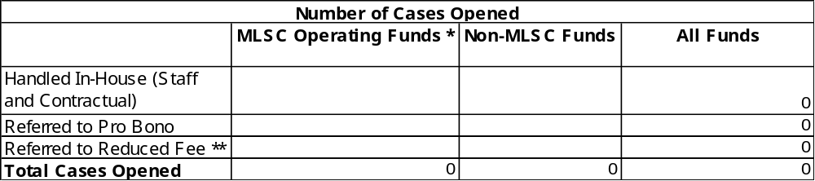* Cases opened under Operating Funds include Operating Grant and Challenge Grant (if any).
** DO NOT report cases here closed under the Judicare Project administered by some MLSC grantees.

b. In addition to cases reported in “a”, above, how many other calls did your program handle during the reporting period that are not reported as opened cases (e.g. callers that are over-income, need assistance with a criminal matter or non-legal matter).

# of additional calls _________

2. Number of Legal Cases Closed - Approximately how many legal cases were closed by your organization in Maryland during the period? Please complete the breakdowns below. Only check the HIGHEST level of service performed as the basis of closure. If your program did not provide direct civil legal representation, leave this item blank.

NOTE: When the service involves court accompaniment by a non-attorney, include the cases in ‘Other Appropriate Remedies’ and indicate in a footnote the number of such cases that are included in that category.

a. Breakdown by Level of Service Provided
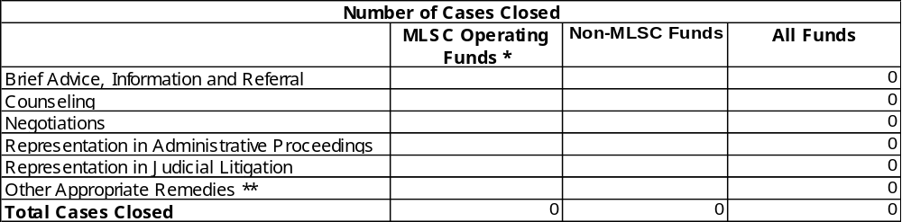 * Cases closed under Operating Funds include Operating Grant and Challenge Grant (if any).
** If "Other Appropriate Remedies" exceeds 10 percent of the total, please attach a breakdown.

b. Breakdown by Service Provider
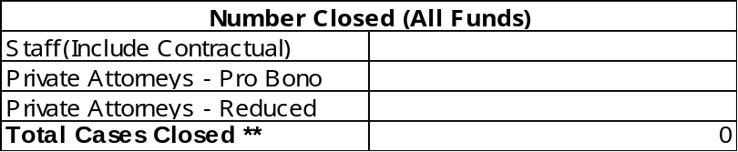
* DO NOT report cases here closed under the separate Judicare Project administered by some MLSC grantees.
** This total should be the same as the "All Funds" total in breakdown "a" above.
B. Direct Civil Representation of Low Income People (continued)
Statistical Report Definitions
Client | A person who is eligible for service and is accepted by the program to receive civil legal services (including advice or other brief services). One client may generate one or more cases.
Organizational Client | MLSC funding may be used to provide legal services to organizations composed primarily of individuals who are themselves eligible to receive MLSC-funded legal assistance. Eligible groups may receive legal representation, such as nonprofit incorporation, by-laws, and community issues such as nuisance abatement. One organizational client may generate one or more cases.
Intake | The process of getting information from a caller or walk-in applicant to determine financial and case acceptance eligibility for civil legal services by staff, pro bono or reduced-fee attorneys.
Case | A distinct civil legal problem or a set of closely related legal problems of a client, and the legal activities or processes used in resolving those problems. A case includes brief services, such as advice, information and/or referral, as well as other types of legal representation. A client with two or more closely related legal problems will be considered as presenting a single case if all of the problems will be resolved through a single legal process or forum. For example, a domestic matter involving the issues of divorce, child custody, support, and visitation is considered one case; if the client also has a landlord/tenant problem it would be counted as a separate case.
Open Case | A case is “opened” when the provider has determined the client’s income eligibility and obtained demographics of age, gender, race and geographic location and affidavit of eligibility. Brief services by telephone may be counted as a case without an affidavit of eligibility.
Closed Case | A case in which there is a resolution of the client's problem(s) and the case is closed, or those instances in which the client's problem is not resolved but it is determined that no further action will be taken on the case.
Impact Case | A civil legal case that (1) affects significant segments of the eligible population, and (2) achieves or is expected to achieve relatively permanent improvement in the legal rights or basic living conditions of those affected. An example of an impact case is an action on behalf of a client or clients resulting in a judicial decision to eliminate a widespread practice of violating rights of low-income tenants. Another example is an action resulting in an administrative decision that effects a change in eligibility criteria for a public benefits program. An impact case is not defined solely by complexity or high level of effort – for example, a case should not be deemed “impact” solely because it took 100 hours to resolve.
Additional Calls | In addition to cases defined above, the number of calls your program handled during the reporting period that are not reported as opened cases (e.g. callers that are over-income, need assistance with a criminal matter or non-legal matter).
Rejected Applicants | Applicants that have a civil legal problem and are financially eligible but are turned away because of lack of program resources, conflict of interest, not in program’s priorities or other reason.
Handled In-House | Although most cases involve some work by in-house staff or contractual attorney (i.e., intake, factual work-up, etc.), cases reported as "handled in-house" should reflect only those cases opened which will be resolved by project staff or contractual attorney without referral to a pro bono or reduced-fee panel attorney.
Referred to Pro Bono | Cases reported in this category are cases that have been opened by the project and referred to a volunteer attorney affiliated with the project who has offered to represent the client without charging a fee, with case closure information expected to be reported back to the project.
Referred to Reduced Fee | Cases reported in this category are cases that have been opened by the project and referred to an attorney affiliated with the project who has agreed to represent the client at a significantly reduced hourly rate or flat fee, with case closure information expected to be reported back to the project.
Closed by Staff | Cases in this category have been handled by in-house staff or contractual attorney and have been closed during the reporting period upon resolution by in-house staff or contractual attorney.
Closed by Private Attorneys – Pro Bono | Cases in this category should reflect only those that have been opened and referred to pro bono attorneys for handling, and have been closed during the reporting period upon resolution of the case by the pro bono attorney with case closure information reported back to the project.
Closed by Private Attorneys – Reduced Fee | Cases in this category should reflect only those that have been opened and referred to attorneys handling the case for a reduced fee, and have been closed during the reporting period upon resolution of the case by the reduced fee attorney with case closure information reported back to the project.
Pro Se Assistance | The assistance provided to clients through court-based or other pro se clinics should be reported as either brief services or counseling, depending upon the service provided.  NOTE: Please include a footnote indicating the number of pro se clients that are included in these general categories.
Level of Service (closed cases):
Only include the highest level of service performed as the basis for closure.
Brief Advice, Information and Referral | Action taken at or soon after intake on behalf of a client that resolved a case requiring a minimal amount of staff time and resources (i.e. approximately 30 minutes or less).
Counseling | Preparing and providing advice to the client (e.g., reviewing relevant information and counseling the client on action that might be taken to resolve the issue or dispute).
Negotiations | Cases are to be reported closed through negotiations when an agreement has been reached between the parties and the issues have been resolved without the filing of a law suit.
Administrative Remedies | This category should reflect cases that were closed during the period which were resolved after suit was filed in an administrative tribunal, regardless of whether the case was resolved upon a decision by the administrative tribunal or settlement between the parties.
Judicial Litigation | This category applies to cases that have been closed during the period which were resolved after suit was filed in a state or federal court, regardless of whether the case was resolved upon a decision by the court or settlement between the parties.
Other Appropriate Remedies | This category should be used when other service categories are inappropriate. For example, the resolution of a case through document preparation, such as the drafting of a contract, will or power of attorney should be included here.  NOTE: A breakdown of the remedies reported in this category must be provided if the number of cases reported here exceed 10 percent of the total cases closed. When the service involves court accompaniment by a non-attorney, include the cases in ‘Other Appropriate Remedies’ and indicate in a footnote the number of such cases that are included in that category.

B. Direct Civil Representation of Low Income People (continued)

3. Breakdown of Total by Legal Problem - Please complete the breakdown below.
-- The total here should be the same as the "All Funds" total in item 2 on page 42.
-- See List on this page for legal problems within each category.

NOTE for all Statistical Reporting: Consider past year’s statistics and any other relevant factors. If the total or categorical increase or decrease is greater than 10%, please explain.

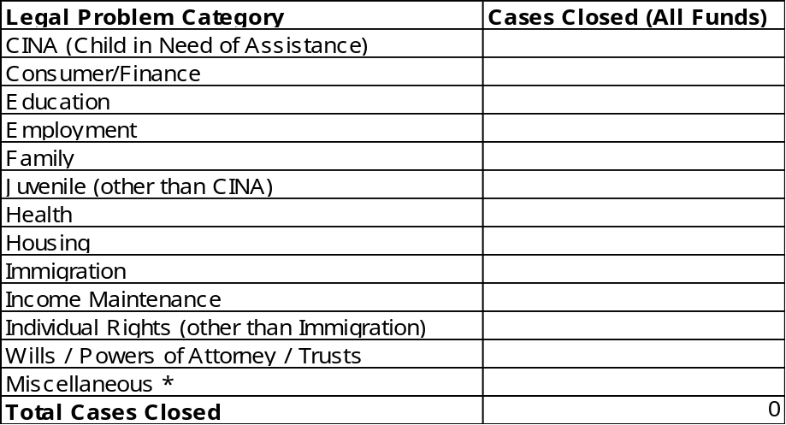

* If “Miscellaneous” exceeds 5 percent of the total, please attach a breakdown.

CINA
Children in Need of Assistance

Consumer/Finance
Bankruptcy/Debtor Relief
Collection/Repossession/Deficiency/
Garnishment
Contracts/Warranties
Credit Access
Energy (Other than Public Utilities)
Loans/Installment Purchase (Other than Collection)

Education
Suspension/Expulsion
Special Education
School Records
Other Education

Employment
Job Discrimination
Wage Claims
Other Employment

Family
Adoption
Custody/Visitation
Divorce/Separation/Annulment
Domestic Violence
Guardianship/Conservatorship
Name Change
Paternal Rights Termination
Paternity
Support
Other Family

Juvenile (other than CINA)
Delinquent
Other Juvenile

Health
Medicaid
Medicare
Other Health

Housing
Federally Subsidized Housing Rights
Home ownership/Real Property
Landlord/Tenant
Public Housing
Other Housing

Immigration/Naturalization
Immigration Status (employment, family and other legal problems should go in other appropriate category)

Income Maintenance
General Support/Other Welfare
Black Lung
Food Stamps/Commodities
Social Security
SSI
Unemployment Compensation
Veterans Benefits
Workers Compensation
Other Income Maintenance

Individual Rights
Mental Health
Prisoner's Rights
Physically Disabled Rights/ADA Issues
Other Individual Rights

Wills/Powers of Attorney/Trusts

Miscellaneous
Incorporation/Dissolution
Indian/Tribal Law
License (Auto & Others)
Torts

B. Direct Civil Representation of Low Income People (continued)

4. Breakdown by County- Please complete the breakdown below. The total here should be the same as the total on the previous page.

NOTE for all Statistical Reporting: Consider past year’s statistics and any other relevant factors. If the total or categorical increase or decrease is greater than 10%, please explain.

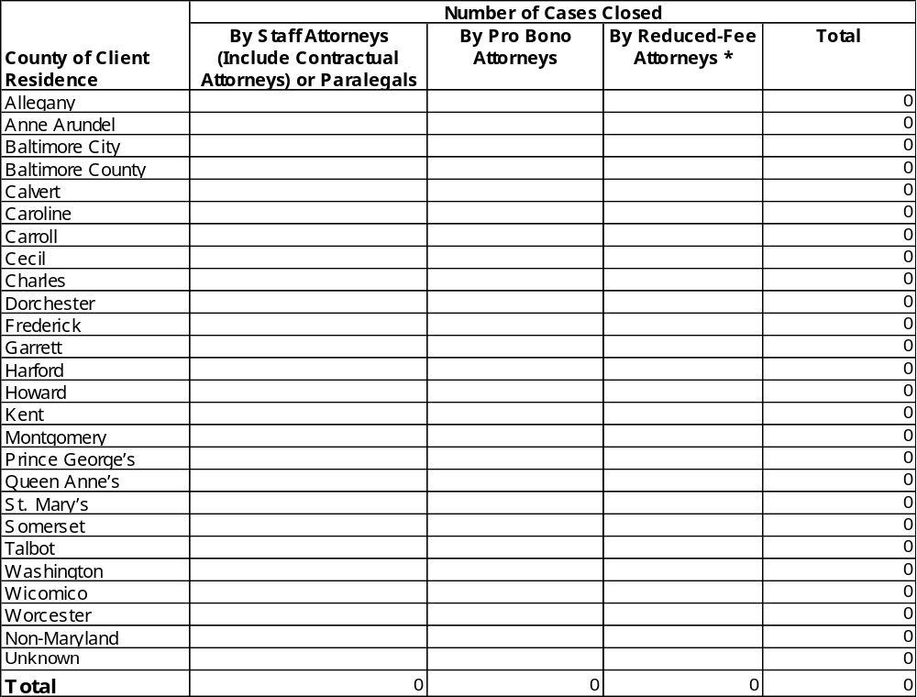

* DO NOT report cases here closed under the separate Judicare Project administered by some MLSC grantees. See definition of Closed by Private Attorney – Reduced Fee on p. 44.

C. Impact Cases

Fill out this section ONLY if during the reporting period (July 1 - December 31) your program had activity on one or more "Impact Cases"- i.e., efforts that meet the following definition:

A civil legal case that (1) affects significant segments of the eligible population, and (2) achieves or is expected to achieve relatively permanent improvement in the legal rights or basic living conditions of those affected. An example of an impact case is an action on behalf of a client or clients resulting in a judicial decision to eliminate a widespread practice of violating rights of low-income tenants. Another example is an action resulting in an administrative decision that effects a change in eligibility criteria for a public benefits program. An impact case is not defined solely by complexity or high level of effort – for example, a case should not be deemed “impact” solely because it took 100 hours to resolve.

1. Number of Impact Cases - Please indicate below the number of impact cases that were active during the reporting period.

Number of Impact Cases That Were Active:

- Example- Provide a brief narrative below summarizing one of the impact cases counted above.

-- Examples of "milestones" might include a decision by a court, a settlement negotiated with an opposing party, a change in behavior by a major employer of low-income people, etc.
-- Examples of "impacts" might include "25 families enabled to avoid possible homelessness", "75 individuals enabled to gain access to job training", etc.

a. Milestones Achieved:

b. Estimated Impacts:

- Number of Individuals Benefiting from All Impact Cases (Estimated): ____________

D. Appealed Cases

1. Number of Appeals- Please indicate the number of appeal cases that were active during the reporting period.
- Number of appeal cases that were active: ____________________

- Total number of staff hours spent during the reporting period on cases reported above: ______________

2. Example- Provide brief narratives of no more than THREE of the appeal cases counted above.
- In your overview, describe in a sentence or two what the case is about.
What are the problems or issues and who is affected?
- Examples of “Results/Outcomes” include the decision by a court and the effects on clients.
- Pick cases that illustrate your program’s best appellate efforts.
- To the extent possible, write for a lay audience; avoid legalese or technical language.

- Overview:

b. Results/Outcomes:

E. Legal Services In-House Staffing

Using the form below, please indicate the total number of Full-Time Equivalent (FTE) paid and volunteer staff persons who were directly involved in the delivery of civil legal services to low-income people (or support of those activities, e.g., training, management, clerical, etc.) during the reporting period.

* Include both MLSC and non-MLSC funded staff persons.
* "Volunteers"- include volunteers who work in your program as staff. Do not include pro bono attorneys.
* Do not include staff not related to legal services- for example, medical counseling.
* A Full-Time Equivalent (FTE) is one or more persons whose hours equal a full-time position. For example, two persons, each working half-time, amount to 1.0 FTE. Express FTE in decimals- for example, 1.5 lawyers.

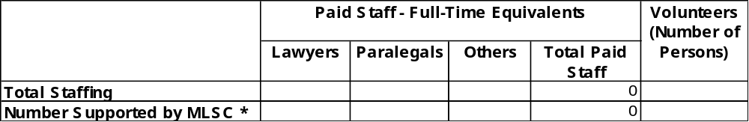

* Number Supported by MLSC: These numbers should match the ones on page 51, Column b.
F. Volunteer/Pro Bono Statistics

1. Number of Volunteers- Using the form below please indicate the total number of volunteers who participated in the delivery of legal services during the reporting period.

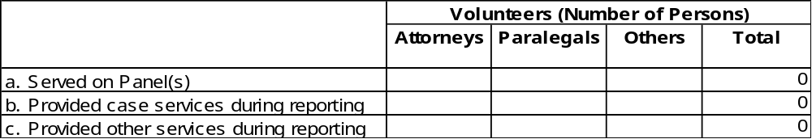

Definitions:

a. "Served on Panel(s)"- Volunteers who currently are signed up to participate in your program; may or may not have been requested to provide services during reporting period.

b. "Provided case services"- Actually accepted or closed one or more "cases" (see definition on page 43) during the reporting period.

c. "Other services"- Includes client services such as pro se training, legal education, etc., as well as in-house services such as intake, answering phones, clerical support, accounting, etc.

2. Hours of Service- Please provide the breakdown below. Use reported figures or estimate, using your best professional judgment.

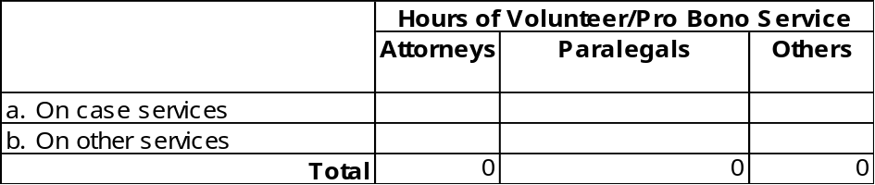

G. Expenditures on Civil Legal Services For The Poor

1. MLSC Operating Budget Status - Please complete the breakdown below. See definitions of line item categories in Part I, pages 18 - 19.

-- MLSC Operating Funds Budgeted (column a): Include your MLSC budget for the total grant period and Challenge Grant (if any).
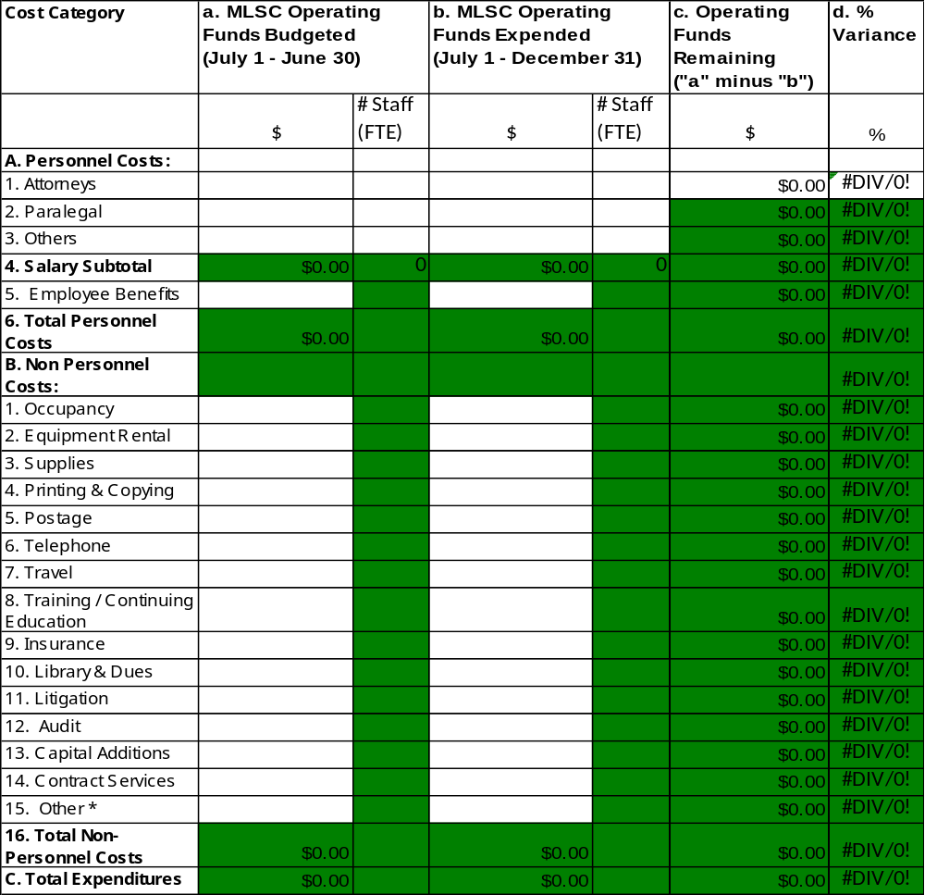
* Other- attach a breakdown if line 15 exceeds 10 percent of the grand total, line "C".

2. Budget Narrative- Describe any significant variations between planned and actual grant expenditures.

Reminder: Any budget revision of MLSC funds, which is more than 10% (see column d) and exceeds by $1,000 that originally approved must be requested in writing and approved by MLSC.
H. One-Time Grant (If Any) – Status and Budget
Note: Report on progress with projects using one-time funds from prior years.

1. Amount of Grant

$____________________ Fiscal Year Awarded:________________________

2. Brief Narrative of Project Status – Describe the purpose of the one-time grant and summarize the progress that your program made during the reporting period.

3. MLSC One-Time Grant Budget Status- Please provide expenditures below.

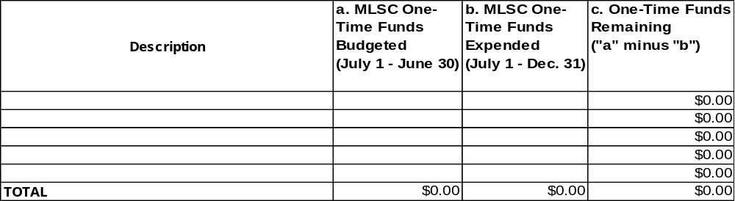

4. Budget Narrative- Please explain any funds remaining. If you wish to request carryover of
unexpended funds, please explain when the expenditures will be completed.

I. Pro Bono Litigation Fund Status (PBRC Only)

1. Amount of Grant

$____________________

- Breakdown of Expenditures- Description should include the name of each organization and use of funds.

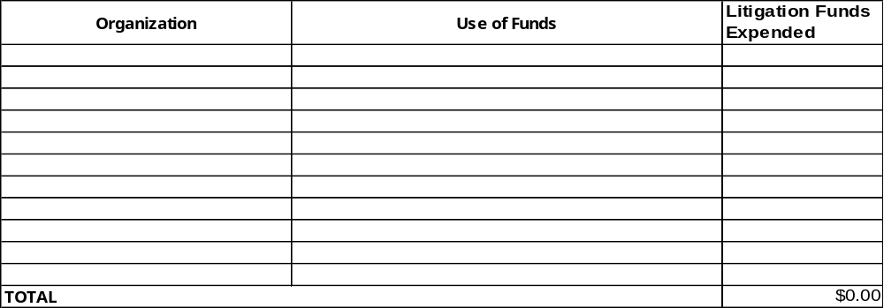
- Comments

J. Other Comments - Use the space below to provide any additional information you feel would assist us in reviewing this report.

MARYLAND LEGAL SERVICES CORPORATION
GRANT APPLICATION

Part IV
Supplement for New Applicants

Recent Past Achievements and Services

This part covers your organization's achievements during the past calendar year ending December 31, in the following areas related to addressing the legal needs of low-income people:

-- Direct civil legal services provided by lawyers, paralegals, and other trained persons (including volunteers), such as those funded under MLSC Civil Legal Services for the poor programs;

-- Other services such as community legal education, administrative and/or legislative advocacy; and,

-- Activities that directly support such services, including outreach, intake, case assignment, legal work supervision, staff training, and administrative support.

If your organization conducted those kinds of activities in Maryland during the past calendar year, please complete this section. If not (for example, if your organization is a newly-formed legal services program), please check "Not Applicable" below and leave this section blank.

____ Not Applicable

A. Snapshot of Past Year's Achievements

Provide here a summary (one page or less) of your program's most significant achievements in Maryland during the past calendar year ending December 31, highlighting any or all of the following:

-- Numbers of people who benefited from your services and the manner, in which they benefited- for example, obtained protection from domestic violence, avoided losing home, etc.

-- Dollar benefits realized by low-income people in Maryland as a direct result of your efforts;

-- Significant developments that affected your program's capacity to deliver legal services, e.g., updating your computer system, obtaining funds for program, etc.
B. Direct Civil Legal Representation of Low Income People

Before completing this section, please review the MLSC statistical reporting definitions on pages 43 & 44.

1. Number of Legal Cases Opened- Approximately how many legal cases were opened by your organization in Maryland during the past calendar year ending December 31? Please complete the breakdown below.

-- If actual data are not available, estimate using your best judgment.
-- If your program did not provide direct civil legal representation, leave this item blank.

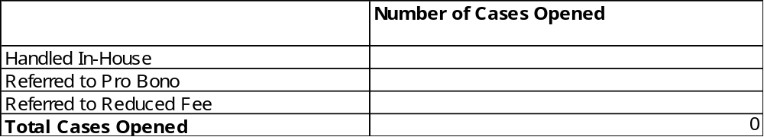

2. Number of Legal Cases Closed- Approximately how many legal cases were closed by your organization in Maryland during the period? Please complete the breakdown below.

-- If actual data are not available, estimate using your best judgment.
-- If your program did not provide direct civil legal representation, leave this item blank.

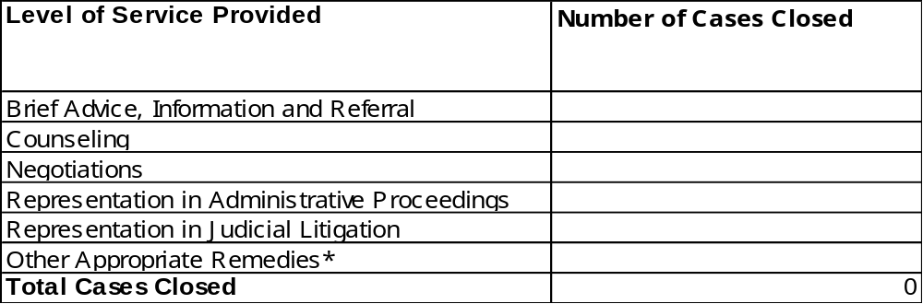

* If "Other Appropriate Remedies" exceeds 10 percent of total cases closed, please provide a breakdown.
B. Direct Civil Representation of Low Income People (continued)

3. Breakdown of Closed Cases by Characteristics of Clients Served- Please complete the breakdowns below. The "Total Cases Closed" should equal the total in item "2" on page 56.

a. Breakdown by Age
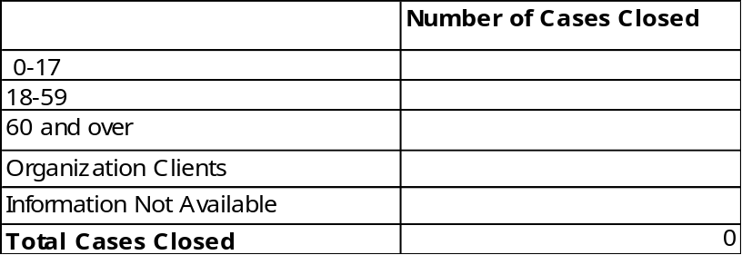

b. Breakdown by Sex
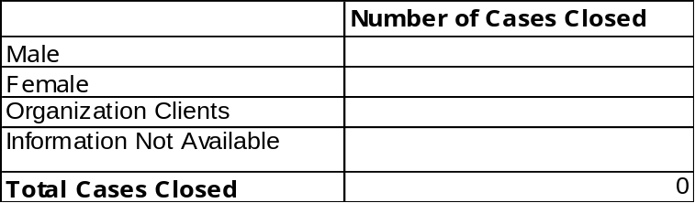

c. Breakdown by Race
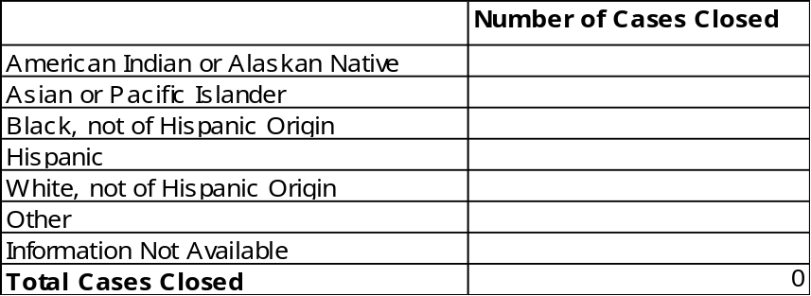

4. Source of data- What was the source of data used in preparing the breakdown in Section B?
a. Statistical reports prepared for other funding agency- specify:

b. Program records.

c. Best estimate based on professional judgment.
B. Direct Civil Representation of Low Income People (continued)

5. Breakdown of Total by Legal Problem - Please complete the breakdown below. The total here should be the same as the total in item "2" on page 56.

-- See list on this page for legal problems within each category.
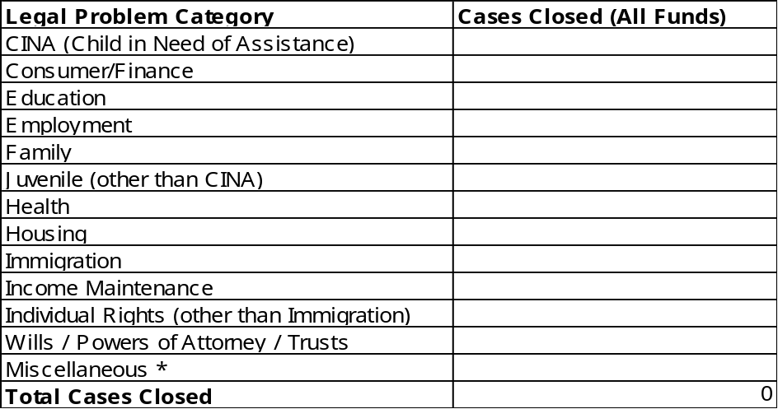
* If “Miscellaneous” exceeds 5 percent of the total, please attach a breakdown.

CINA
Children in Need of Assistance

Consumer/Finance
Bankruptcy/Debtor Relief
Collection/Repossession/Deficiency/
Garnishment
Contracts/Warranties
Credit Access
Energy (Other than Public Utilities)
Loans/Installment Purchase (Other than Collection)

Education
Suspension/Expulsion
Special Education
School Records
Other Education

Employment
Job Discrimination
Wage Claims
Other Employment

Family
Adoption
Custody/Visitation
Divorce/Separation/Annulment
Domestic Violence
Guardianship/Conservatorship
Name Change
Paternal Rights Termination
Paternity
Support
Other Family

Juvenile (other than CINA)
Delinquent
Other Juvenile

Health
Medicaid
Medicare
Other Health

Housing
Federally Subsidized Housing Rights
Home ownership/Real Property
Landlord/Tenant
Public Housing
Other Housing

Immigration/Naturalization
Immigration Status (employment, family and other legal problems should go in other appropriate category)

Income Maintenance
General Support/Other Welfare
Black Lung
Food Stamps/Commodities
Social Security
SSI
Unemployment Compensation
Veterans Benefits
Workers Compensation
Other Income Maintenance

Individual Rights
Mental Health
Prisoner's Rights
Physically Disabled Rights/ADA Issues
Other Individual Rights

Wills/Powers of Attorney/Trusts

Miscellaneous
Incorporation/Dissolution
Indian/Tribal Law
License (Auto & Others)
Torts

B. Direct Civil Legal Representation of Low Income People (continued)

6. Definition of "Case" Used for Statistical Reporting Purposes- Please check line below that best describes your organization's definition of a "case" for statistical reporting purposes.

Check ONE only:

a. We use MLSC's definition of a "case"- see page 43.

b. We use a different definition, which is as follows (briefly describe below):

7. Examples of Typical Cases-

-- Using only this page please provide one or two vignettes (brief narrative examples, or snapshots) of recent "typical" cases such as you might use in describing your program's services to the public.
-- Use examples that illustrate the human impact of the case statistics provided elsewhere in this report.
-- Write for a lay audience; avoid legalese or technical language.
-- Include news clippings or other interesting descriptive materials, if available, as an attachment.

Example 1:

Example 2:
C. Impact Cases

Fill out this section ONLY if during the calendar year ending December 31 your program had activity on one or more "Impact Cases"- i.e., efforts that meet the following definition:

A civil legal case that (1) affects significant segments of the eligible population, and (2) achieves or is expected to achieve relatively permanent improvement in the legal rights or basic living conditions of those affected. An example of an impact case is an action on behalf of a client or clients resulting in a judicial decision to eliminate a widespread practice of violating rights of low-income tenants. Another example is an action resulting in an administrative decision that effects a change in eligibility criteria for a public benefits program. An impact case is not defined solely by complexity or high level of effort – for example, a case should not be deemed “impact” solely because it took 100 hours to resolve.

1. Number of Impact Cases - Please indicate below the number of impact efforts that were active in the past calendar year.

Number of Impact Cases That Were Active:

2. Example - Provide a brief narrative below summarizing one of the impact cases counted above.

-- Examples of "milestones" might include a decision by a court, a settlement negotiated with an opposing party, a change in behavior by a major employer of low-income people, etc.
-- Examples of "impacts" might include "25 families enabled to avoid possible homelessness", "75 individuals enabled to gain access to job training", etc.

a. Milestones Achieved:

b. Estimated Impacts:

3. Number of Individuals Benefiting from All Impact Cases (Estimated): ____________
D. Services Other Than Case Services

This section provides an opportunity for your program to describe any services (related to civil legal services for the poor) it provides in addition to or other than direct legal representation.

1. Services Provided - Provide below a brief overview, or summary description, of any services (related to legal services for the poor) provided by your program OTHER than case services described in sections B and C.

-- Examples: Statewide support for other legal services providers, community legal education, etc.

-- Do not include services not related to legal services for the poor- for example, medical or shelter services.

2. Examples of Significant Non-Case Services - Please provide not more than two brief narrative examples that illustrate the kinds of services summarized in "1" above. Highlight the following:

-- Who was the target audience of the services?
-- What needs of that audience were addressed?
-- What results were achieved?
-- What quantitative results were achieved- for example, "75 lawyers were trained", or "125 low income people attended this clinic".
E. Pro Bono Private Attorney Involvement

Fill out this section ONLY if during the calendar year ending December 31 your program involved pro bono private attorneys in delivering legal services to low-income people.

1. Pro Bono Program Overview - Briefly describe below your organization's private attorney involvement program(s), especially highlighting variations (if any) from the traditional "referral panel" model of program design.

2. Pro Bono Involvement Statistics - Please complete items a-d below. "Reporting Period" means the past calendar year ending December 31.

a. Estimated number of practicing private attorneys in the program’s service area (excluding judges and others not available to assist in serving eligible clients):
b. Total number of private attorneys participating in pro bono program at end of reporting period:
c. Total number of cases accepted by pro bono attorneys during the reporting period:
d. Total number of hours of service provided by private attorneys on a pro bono basis (estimate):

3. Activities for Encouraging Pro Bono Involvement- Describe- for example, "We published a full-page ad recognizing our pro bono attorneys".

